FAQ.

if you are not familiar with git please see the youtube video given below.

<http://www.youtube.com/watch?v=mYjZtU1-u9Y>

1. Where is the scrumretro.com code available?

https://github.com/scrumretrospective/sr

2. How to check out code from scrumretro.com git repository?

-- install git in your development machine.

--if you are using linux --execute the command in the next line in a shell

sudo apt-get install git

--if you are using windows -- download and install git from location given below.

http://msysgit.github.com/

--Now execute the following command from shell/command prompt

git clone https://github.com:/scrumretrospective/sr

3. How to setup project in eclipse.

--import maven project from the code checked out location

--see the screenshot

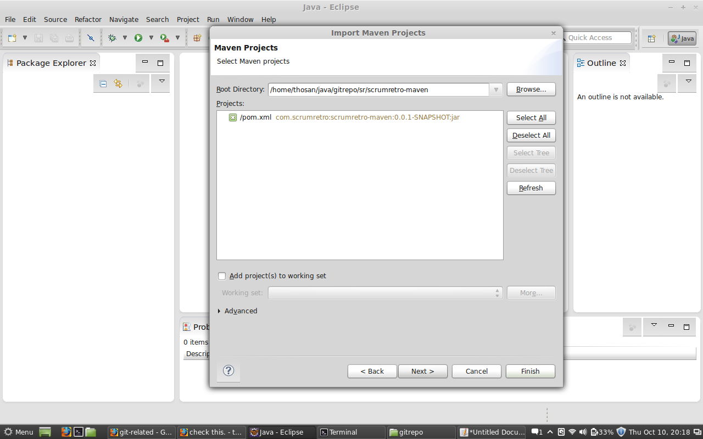

4. Changing the maven settings.xml

-- update the settings.xml in the project root folder to point it to your local repo.

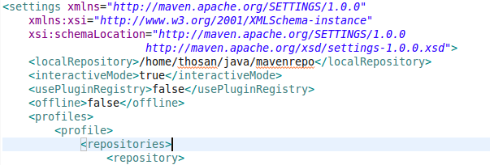

5. How to commit/snapshot the code to git local repository?

--when ever you get a working copy of the code you may commit that code to your local repo. so that you can revert to that version or branch out that version anytime you like.

set yourself as the current user.

thosan@thosan-hp ~/java/gitrepo/sr $ git config --global user.email scrumretrospective@gmail.com

thosan@thosan-hp ~/java/gitrepo/sr $ git config --global user.name scrumretrospective

--move the file to staging area

thosan@thosan-hp ~/java/gitrepo/sr $ git add .

git status -- will list out all the new files added to local repo

--now commit.

git commit -m "user story number"[master b341ef1] user story number

6. How to check in to remote repository?

command line :

thosan@thosan-hp ~/java/gitrepo/sr $ git push

warning: push.default is unset; its implicit value is changing in

Git 2.0 from 'matching' to 'simple'. To squelch this message

and maintain the current behavior after the default changes, use:

git config --global push.default matching

To squelch this message and adopt the new behavior now, use:

git config --global push.default simple

See 'git help config' and search for 'push.default' for further information.

(the 'simple' mode was introduced in Git 1.7.11. Use the similar mode

'current' instead of 'simple' if you sometimes use older versions of Git)

Username for 'https://github.com': scrumretrospective

Password for 'https://scrumretrospective@github.com':

Counting objects: 45, done.

Delta compression using up to 2 threads.

Compressing objects: 100% (14/14), done.

Writing objects: 100% (25/25), 1.64 KiB, done.

Total 25 (delta 6), reused 0 (delta 0)

To https://github.com/scrumretrospective/sr.git

8bea7ec..17080e1 master -> master

thosan@thosan-hp ~/java/gitrepo/sr $

Eclipse screen shots below.

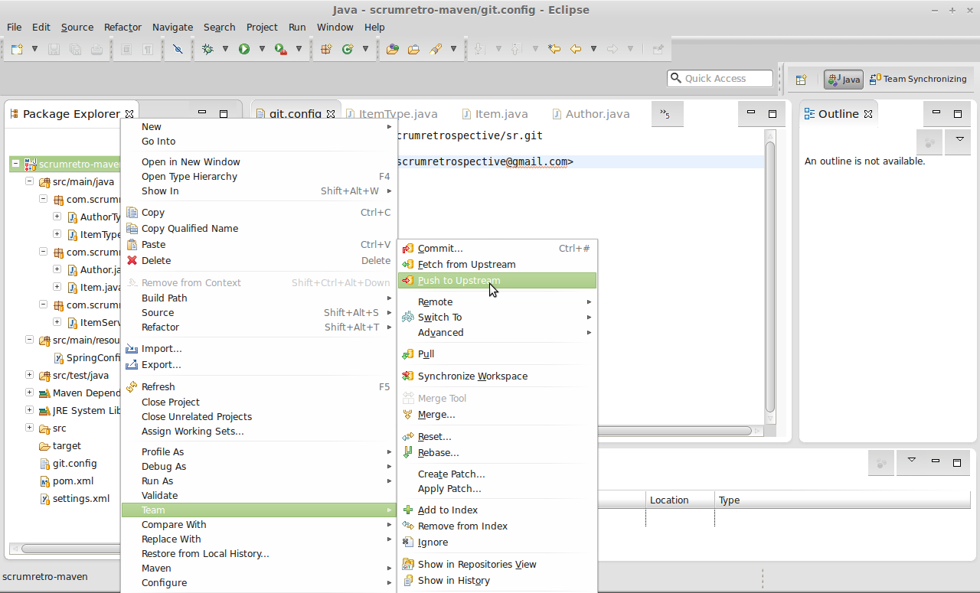

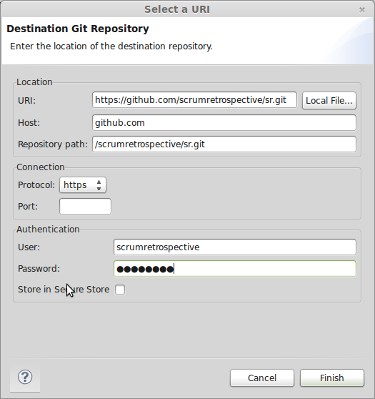

Best practices to follow.

1. Every feature shall be developed in local branch.